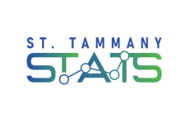
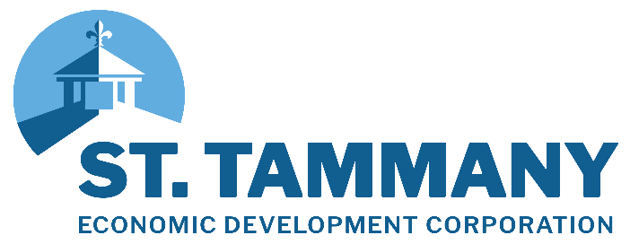

FOR IMMEDIATE RELEASE: June 12, 2025

St. Tammany Economic Development Corporation Releases 2025 First Quarter Economic Trends in Latest Edition of The AnalyST

COVINGTON, LA – St. Tammany Economic Development Corporation (St. Tammany EDC) has released the latest edition of their digital research publication, The AnalyST. This economic trends report highlights important data-driven indicators that were seen across our local, state, and national economies during the first quarter of 2025. Although these economic landscapes continue to evolve, this quarterly report offers an opportunity to look back, underscoring the dynamic shifts that were influencing industries, employment trends, and financial markets.
With key research insights from our economic advisors at Economic Leadership, LLC, a national economic development and strategic planning consultancy group, The AnalyST covers a range of topics including inflation, the labor market, housing trends, consumer spending, and other industry-specific information.
Key Findings:
- Labor Market Developments: Unemployment in St. Tammany Parish rose slightly to around 4%, but it remains below metro, state, and national averages, indicating a tight labor market still within the natural unemployment rate of 3.5% to 4.5%. Revised data from the Bureau of Labor Statistics shows the parish’s labor force is now 6,650 workers larger than in March 2020, although the labor force participation rate remains at 58.3%. The employment-to-population ratio has improved for prime-age workers (ages 25–54), but remains low for younger and older age groups, with employment more prevalent among individuals holding a bachelor’s degree or higher.

- Business & Industry: There were 931 new business incorporation filings in Q1 2025 - a slight decline of 74 compared to the same quarter last year. Self-employment remains strong, accounting for 36% of all jobs, particularly in real estate, agriculture, finance, and professional services. The manufacturing sector experienced a decline in the Purchasing Managers’ Index (PMI) during early 2025 due to trade policy uncertainty, accompanied by a slight increase in manufacturing-related unemployment. In the services sector, the PMI held at 51.6%, signaling continued economic expansion, though a small and unusual rise in unemployment was observed between February and March.

- Inflation & Wages: Inflation in the Southern region reached the Federal Reserve’s 2% year-over-year target in March 2025, though elevated prices persist in housing, childcare, and dining, with tariffs impacting further price increases, especially for vehicles. Wage growth in the region has stabilized at a 3.3% annual rate, with average weekly earnings in St. Tammany Parish at $1,104; however, adjusted for cost of living, real wages are less compared to broader benchmarks.

- Real Estate & Construction: In Q1 2025, 293 new housing units were permitted in St. Tammany Parish, a slight year-over-year decline of 8 units, with average unit value falling by approximately $14,000 and multifamily development remaining limited and below pre-pandemic levels. The residential market saw a 5.1% increase in home sales in April 2025 compared to the previous year, with a typical home value of $286,850—substantially more affordable than the national average—and values rising at a modest and sustainable annual rate of 0.8%.

- Retail Sales & Consumer Activity: Retail sales tax collections reached $29.1 million in March 2025, a 6.9% increase from the previous year, and first-quarter collections were $6 million higher than Q1 2024, likely driven by the recent state sales tax increase from 4% to 5% and consumer purchases made ahead of anticipated tariffs.
“As the economic development organization for St. Tammany Parish, it is part of our responsibility to provide timely, data-driven insights that empower our business community and local leaders to make informed decisions,” said Chris Masingill, CEO of St. Tammany Economic Development Corporation. “Through this quarterly report, St. Tammany EDC delivers critical economic insights that help our strategic partners navigate challenges and seize opportunities, thus reaffirming our commitment to shaping a resilient and prosperous future for our region.”

This edition of The AnalyST can be accessed on St. Tammany EDC’s website at www.sttammanyedc.org/the-analyst.

###

About St. Tammany Economic Development Corporation: As the economic development organization for St. Tammany, St. Tammany Economic Development Corporation (St. Tammany EDC) serves as the comprehensive resource center for business services throughout the parish. St. Tammany EDC’s services include business retention, site selection, workforce development, research and data services, state and local incentives, business attraction, talent retention, certified site development, relocation support, and marketing St. Tammany. Since the organization’s launch in 2018, St. Tammany EDC facilitated business expansion and attraction announcements representing over $291.9 million in capital investment and 2,299 new and retained jobs in St. Tammany Parish. For more information about St. Tammany EDC, please visit stttammanyedc.org.

Media Contact
- Kristin Durand, Director of Communications
- kdurand@sttammanyedc.org
- 985.809.7874

